The Key to Vibrant Health:
Nourishing Traditional Diets
A presentation from the best-selling author
Sally Fallon Morell, president, the Weston A. Price Foundation
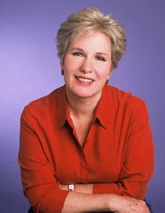
Learn how to regain and maintain your health …naturally!

Where? Woodrow Wilson High School
3950 Chesapeake St NW, DC
When? Sunday, May 1, 2016
5:30-7:30 (doors open at 5:00)
Cost: $10 donation suggested
Questions? info@westonaprice.org

This presentation is based on the research of Dr. Weston A. Price,who studied the diets of healthy isolated peoples throughout the globe.
The event will be broadcast LIVE for the Wise Traditions podcast, with host and M.C. Hilda Labrada Gore.

